**UUS**

**Ns = [100, 500, 1000, 5000, 10000]**

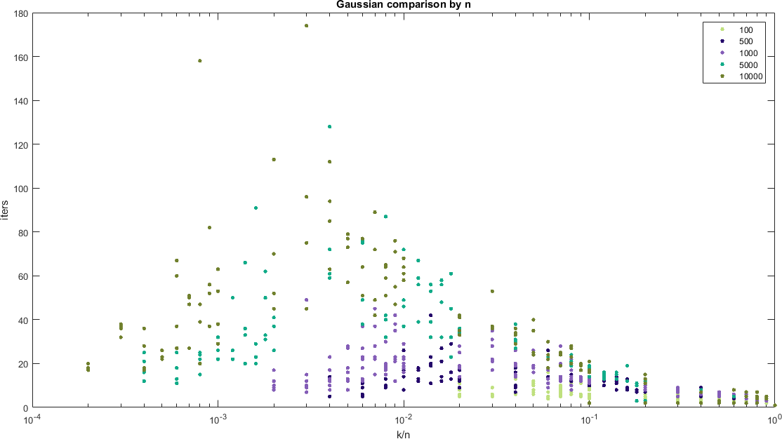

**UUC**

**Ns = [100, 500, 1000, 5000, 10000]**

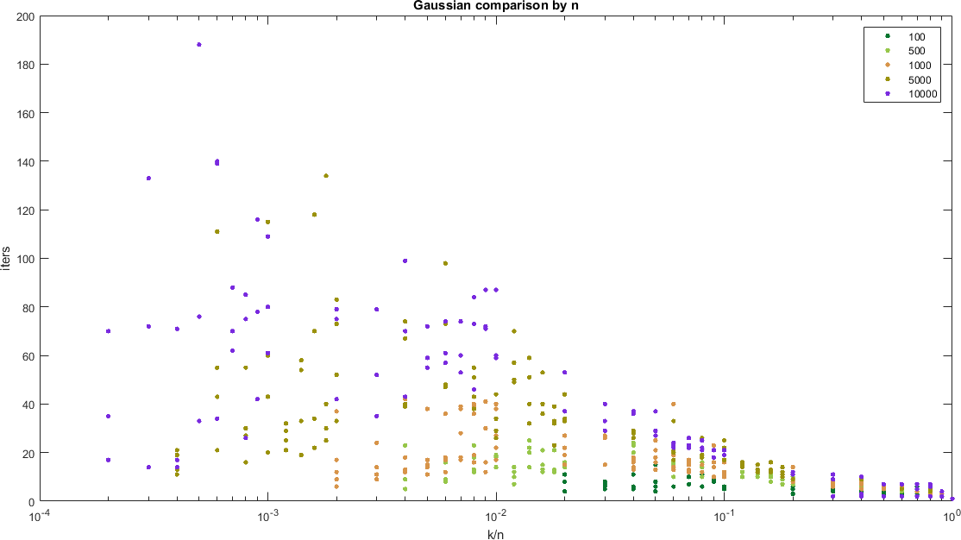

**Gaussian 1c sym sph orig**

**Sigs = [1, 5, 10]**

**Ns = [100, 500, 1000, 5000, 10000]**

